DBMS Mini Project

Gautam Krishna – PES2UG24CS169
Divyanshi Verma – PES2UG24CS161
CivicPulse - A platform for citizens to report municipal issues, track their complaints, and help authorities assign, resolve, and manage complaints efficiently.

Task 1 — Project Title & Problem Statement

Project Title
A platform for citizens to report municipal issues, track their complaints, and help authorities assign, resolve, and manage complaints efficiently.

Problem Statement
Citizens report civic issues — potholes, uncollected garbage, broken streetlights, water stagnation — through phone helplines, social media, and disconnected portals. Three failures follow. First, complaints are routed to departments manually, so they sit unassigned for days. Second, the same physical issue is reported dozens of times by different residents, flooding the queue with duplicates that hide the true backlog. Third, nobody is held to a deadline: there is no per-category service-level agreement, no automatic escalation when it lapses, and no ward-wise accountability data for the public.
CivicPulse addresses all three at the database layer. Every issue category carries its own SLA, from which each complaint's deadline is derived automatically on insert. Complaints are auto-routed to the least-loaded available field officer in the owning department by a stored procedure that runs as a single atomic transaction. Incoming complaints are checked against existing open complaints in the same ward using full-text search (extensible to vector similarity), so near-duplicates are linked to a parent rather than re-queued. Every status transition is written to an immutable audit trail by a trigger, and ward-level resolution performance is exposed through views.

Why this is not a simple CRUD application
- Automatic SLA derivation: deadlines are computed from category metadata by a database trigger, not hard-coded in the application.
- Non-trivial routing: workload-balanced assignment across staff requires a multi-statement transaction that reads capacity, deactivates prior assignments, increments load, and flips status atomically.
- Duplicate detection: a self-referencing relationship (duplicate_of) plus full-text ranking clusters redundant reports — this is a retrieval problem, not a lookup.
- Immutable audit trail: status history is written by a trigger so it cannot be bypassed by the application layer.
- Multi-level escalation workflow with inter-departmental hand-off, plus public prioritisation through upvotes.

Database technology justification
The operational core — citizens, staff, wards, departments, complaints, assignments, escalations — demands strict referential integrity and multi-statement atomicity (a routing operation that half-completes would corrupt staff workload counters). This is squarely relational, so PostgreSQL is used as the mandatory SQL database. The free-text complaint descriptions are the natural companion workload for a vector database: embedding each description into pgvector would let CivicPulse match “water logging near the bus stand” to an existing “stagnant rainwater at depot road” complaint that shares no keywords, which full-text search alone cannot do. This satisfies the SQL + Vector Database option in the project brief. Week 4 delivers the mandatory SQL component; the schema already carries the search_vector column and the duplicate_of relationship that the vector layer will populate.

Task 2 — ER Diagram & Relational Schema

Entity-Relationship Diagram

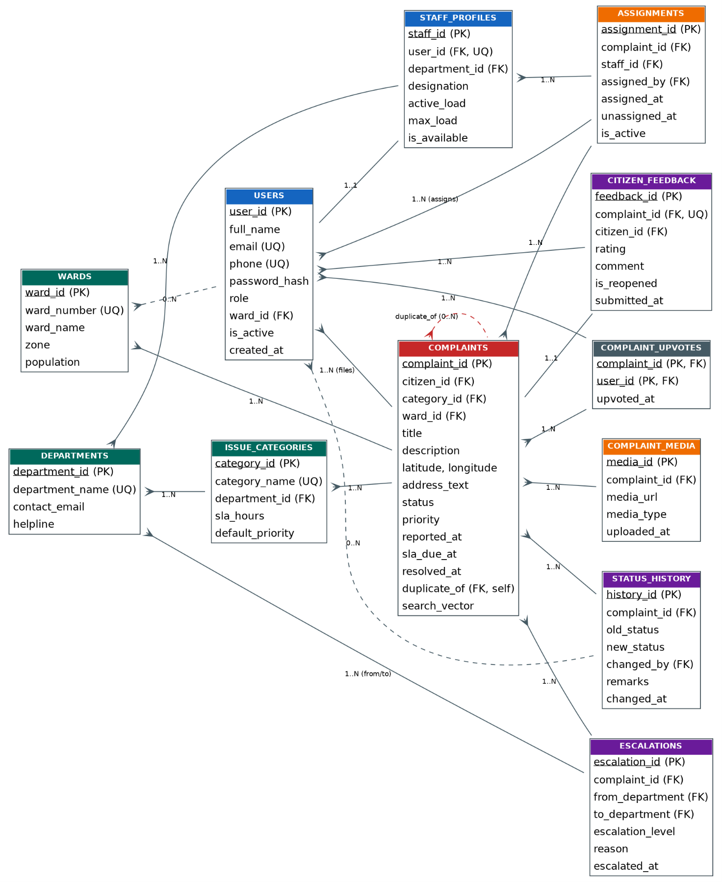

Relational Schema
The ER diagram converts into the following twelve relations. Note two design points carried over from ER analysis: STAFF_PROFILES is a specialisation of USERS (one-to-one, enforced by a UNIQUE foreign key) rather than a duplicate identity table, and COMPLAINT_UPVOTES is a pure associative entity with a composite primary key and no surrogate key.

1. wards(ward_id PK, ward_number, ward_name, zone, population)
Column | Type / Constraint
ward_id | PK, SERIAL
ward_number | INT, NOT NULL, UNIQUE
ward_name | VARCHAR(100), NOT NULL
zone | VARCHAR(50), NOT NULL
population | INT, CHECK >= 0

2. departments(department_id PK, department_name, contact_email, helpline)
Column | Type / Constraint
department_id | PK, SERIAL
department_name | VARCHAR(100), NOT NULL, UNIQUE
contact_email | VARCHAR(150), NOT NULL
helpline | VARCHAR(20)
3. issue_categories(category_id PK, category_name, department_id FK, sla_hours, default_priority)
Column | Type / Constraint
category_id | PK, SERIAL
category_name | VARCHAR(100), NOT NULL, UNIQUE
department_id | FK → departments(department_id), ON DELETE RESTRICT
sla_hours | INT, NOT NULL, CHECK > 0
default_priority | VARCHAR(10), CHECK IN (low, medium, high, critical)
4. users(user_id PK, full_name, email, phone, password_hash, role, ward_id FK, is_active, created_at)
Column | Type / Constraint
user_id | PK, SERIAL
full_name | VARCHAR(100), NOT NULL
email | VARCHAR(150), NOT NULL, UNIQUE
phone | VARCHAR(15), UNIQUE
password_hash | VARCHAR(255), NOT NULL
role | VARCHAR(20), CHECK IN (citizen, staff, supervisor, admin)
ward_id | FK → wards(ward_id), ON DELETE SET NULL
is_active | BOOLEAN, NOT NULL, DEFAULT TRUE
5. staff_profiles(staff_id PK, user_id FK, department_id FK, designation, active_load, max_load, is_available)
Column | Type / Constraint
staff_id | PK, SERIAL
user_id | FK → users(user_id), UNIQUE (1:1 specialisation), ON DELETE CASCADE
department_id | FK → departments(department_id), ON DELETE RESTRICT
designation | VARCHAR(80)
active_load | INT, CHECK >= 0, DEFAULT 0
max_load | INT, CHECK > 0, DEFAULT 15
is_available | BOOLEAN, NOT NULL, DEFAULT TRUE

6. complaints(complaint_id PK, citizen_id FK, category_id FK, ward_id FK, title, description, latitude, longitude, address_text, status, priority, reported_at, sla_due_at, resolved_at, duplicate_of FK, search_vector)
Column | Type / Constraint
complaint_id | PK, SERIAL
citizen_id | FK → users(user_id), ON DELETE RESTRICT
category_id | FK → issue_categories(category_id)
ward_id | FK → wards(ward_id)
title / description | VARCHAR(150) / TEXT, both NOT NULL
latitude / longitude | NUMERIC(9,6), CHECK within valid geo ranges
status | VARCHAR(20), CHECK IN (open, assigned, in_progress, resolved, rejected, duplicate)
priority | VARCHAR(10), NOT NULL, inherited from category by trigger
sla_due_at | TIMESTAMP, derived by trigger from category sla_hours
resolved_at | TIMESTAMP, CHECK >= reported_at
duplicate_of | FK → complaints(complaint_id) (self-referencing), CHECK <> self
search_vector | tsvector GENERATED ALWAYS AS (...) STORED — full-text index source
7. complaint_media(media_id PK, complaint_id FK, media_url, media_type, uploaded_at)
Column | Type / Constraint
media_id | PK, SERIAL
complaint_id | FK → complaints(complaint_id), ON DELETE CASCADE
media_url | VARCHAR(255), NOT NULL
media_type | VARCHAR(10), CHECK IN (image, video, audio)
8. assignments(assignment_id PK, complaint_id FK, staff_id FK, assigned_by FK, assigned_at, unassigned_at, is_active)
Column | Type / Constraint
assignment_id | PK, SERIAL
complaint_id | FK → complaints(complaint_id), ON DELETE CASCADE
staff_id | FK → staff_profiles(staff_id), ON DELETE RESTRICT
assigned_by | FK → users(user_id)
unassigned_at | TIMESTAMP, CHECK >= assigned_at
is_active | BOOLEAN; PARTIAL UNIQUE INDEX on (complaint_id) WHERE is_active

9. status_history(history_id PK, complaint_id FK, old_status, new_status, changed_by FK, remarks, changed_at)
Column | Type / Constraint
history_id | PK, SERIAL
complaint_id | FK → complaints(complaint_id), ON DELETE CASCADE
old_status / new_status | VARCHAR(20); new_status NOT NULL
changed_by | FK → users(user_id), NULLABLE (system-generated rows)
changed_at | TIMESTAMP, DEFAULT CURRENT_TIMESTAMP
10. escalations(escalation_id PK, complaint_id FK, from_department FK, to_department FK, escalation_level, reason, escalated_at)
Column | Type / Constraint
escalation_id | PK, SERIAL
complaint_id | FK → complaints(complaint_id), ON DELETE CASCADE
from_department / to_department | FK → departments(department_id)
escalation_level | SMALLINT, CHECK BETWEEN 1 AND 3
reason | VARCHAR(255), NOT NULL
11. citizen_feedback(feedback_id PK, complaint_id FK, citizen_id FK, rating, comment, is_reopened, submitted_at)
Column | Type / Constraint
feedback_id | PK, SERIAL
complaint_id | FK → complaints(complaint_id), UNIQUE (1:1), ON DELETE CASCADE
citizen_id | FK → users(user_id), ON DELETE CASCADE
rating | SMALLINT, NOT NULL, CHECK BETWEEN 1 AND 5
is_reopened | BOOLEAN, NOT NULL, DEFAULT FALSE
12. complaint_upvotes(complaint_id PK/FK, user_id PK/FK, upvoted_at)
Column | Type / Constraint
complaint_id, user_id | COMPOSITE PK; both FK, ON DELETE CASCADE
upvoted_at | TIMESTAMP, DEFAULT CURRENT_TIMESTAMP

Task 3 — DDL Statements
The DDL targets PostgreSQL (the mandatory SQL database per the project brief). Beyond the twelve CREATE TABLE statements, it provisions indexes, two views, two triggers, a stored procedure and a search function — pre-satisfying five of the required Advanced Database Features:
Advanced Feature | Implemented As | Verified By
Indexing | 10 indexes incl. a GIN full-text index and two partial indexes | \di listing after execution
Views | sla_breach_view, ward_performance_view | CREATE VIEW × 2 in execution log
Triggers | fn_set_sla_due (BEFORE INSERT), fn_log_status_change (BEFORE UPDATE) | Functional Tests 1 and 3
Stored procedures | sp_auto_assign_complaint — workload-balanced routing | Functional Test 2
Full-text search | tsvector column + fn_find_similar_complaints() | Functional Test 4

The complete script follows, and is also supplied as an attached .sql file.
-- =====================================================================
-- Project: CivicPulse - Municipal Civic Grievance Reporting, Routing
-- and SLA Escalation Platform with Duplicate-Complaint Detection
-- Week 4 DBMS Lab - DDL Statements (PostgreSQL)
-- =====================================================================

DROP TABLE IF EXISTS complaint_upvotes, citizen_feedback, escalations,
status_history, assignments, complaint_media, complaints, staff_profiles,
users, issue_categories, departments, wards CASCADE;

-- 1. WARDS -----------------------------------------------------------------
CREATE TABLE wards (
ward_id SERIAL PRIMARY KEY,
ward_number INT NOT NULL UNIQUE,
ward_name VARCHAR(100) NOT NULL,
zone VARCHAR(50) NOT NULL,
population INT CHECK (population >= 0)
);

-- 2. DEPARTMENTS -----------------------------------------------------------
CREATE TABLE departments (
department_id SERIAL PRIMARY KEY,
department_name VARCHAR(100) NOT NULL UNIQUE,
contact_email VARCHAR(150) NOT NULL,
helpline VARCHAR(20)
);

-- 3. ISSUE_CATEGORIES ------------------------------------------------------
-- Each category is owned by exactly one department and carries its own SLA.
CREATE TABLE issue_categories (
category_id SERIAL PRIMARY KEY,
category_name VARCHAR(100) NOT NULL UNIQUE,
department_id INT NOT NULL REFERENCES departments(department_id) ON DELETE RESTRICT,
sla_hours INT NOT NULL CHECK (sla_hours > 0),
default_priority VARCHAR(10) NOT NULL DEFAULT 'medium'
CHECK (default_priority IN ('low','medium','high','critical'))
);

-- 4. USERS -----------------------------------------------------------------
CREATE TABLE users (
user_id SERIAL PRIMARY KEY,
full_name VARCHAR(100) NOT NULL,
email VARCHAR(150) NOT NULL UNIQUE,
phone VARCHAR(15) UNIQUE,
password_hash VARCHAR(255) NOT NULL,
role VARCHAR(20) NOT NULL DEFAULT 'citizen'
CHECK (role IN ('citizen','staff','supervisor','admin')),
ward_id INT REFERENCES wards(ward_id) ON DELETE SET NULL,
is_active BOOLEAN NOT NULL DEFAULT TRUE,
created_at TIMESTAMP NOT NULL DEFAULT CURRENT_TIMESTAMP
);

-- 5. STAFF_PROFILES --------------------------------------------------------
-- Specialisation of USERS: only users with role 'staff'/'supervisor' appear.
CREATE TABLE staff_profiles (
staff_id SERIAL PRIMARY KEY,
user_id INT NOT NULL UNIQUE REFERENCES users(user_id) ON DELETE CASCADE,
department_id INT NOT NULL REFERENCES departments(department_id) ON DELETE RESTRICT,
designation VARCHAR(80),
active_load INT NOT NULL DEFAULT 0 CHECK (active_load >= 0),
max_load INT NOT NULL DEFAULT 15 CHECK (max_load > 0),
is_available BOOLEAN NOT NULL DEFAULT TRUE
);

-- 6. COMPLAINTS ------------------------------------------------------------
-- duplicate_of is a self-referencing FK used by the duplicate-detection module.
CREATE TABLE complaints (
complaint_id SERIAL PRIMARY KEY,
citizen_id INT NOT NULL REFERENCES users(user_id) ON DELETE RESTRICT,
category_id INT NOT NULL REFERENCES issue_categories(category_id) ON DELETE RESTRICT,
ward_id INT NOT NULL REFERENCES wards(ward_id) ON DELETE RESTRICT,
title VARCHAR(150) NOT NULL,
description TEXT NOT NULL,
latitude NUMERIC(9,6) CHECK (latitude BETWEEN -90 AND 90),
longitude NUMERIC(9,6) CHECK (longitude BETWEEN -180 AND 180),
address_text VARCHAR(255),
status VARCHAR(20) NOT NULL DEFAULT 'open'
CHECK (status IN ('open','assigned','in_progress','resolved','rejected','duplicate')),
-- No column DEFAULT here on purpose: leaving it NULL lets the BEFORE INSERT
-- trigger inherit the priority from the issue category. BEFORE triggers fire
-- before NOT NULL is checked, so the row is still guaranteed non-null.
priority VARCHAR(10) NOT NULL
CHECK (priority IN ('low','medium','high','critical')),
reported_at TIMESTAMP NOT NULL DEFAULT CURRENT_TIMESTAMP,
sla_due_at TIMESTAMP,
resolved_at TIMESTAMP,
duplicate_of INT REFERENCES complaints(complaint_id) ON DELETE SET NULL,
-- Generated column powering full-text search (advanced feature)
search_vector tsvector GENERATED ALWAYS AS (
to_tsvector('english', coalesce(title,'') || ' ' || coalesce(description,''))
) STORED,
CHECK (resolved_at IS NULL OR resolved_at >= reported_at),
CHECK (duplicate_of IS NULL OR duplicate_of <> complaint_id)
);

-- 7. COMPLAINT_MEDIA -------------------------------------------------------
CREATE TABLE complaint_media (
media_id SERIAL PRIMARY KEY,
complaint_id INT NOT NULL REFERENCES complaints(complaint_id) ON DELETE CASCADE,
media_url VARCHAR(255) NOT NULL,
media_type VARCHAR(10) NOT NULL CHECK (media_type IN ('image','video','audio')),
uploaded_at TIMESTAMP NOT NULL DEFAULT CURRENT_TIMESTAMP
);

-- 8. ASSIGNMENTS -----------------------------------------------------------
CREATE TABLE assignments (
assignment_id SERIAL PRIMARY KEY,
complaint_id INT NOT NULL REFERENCES complaints(complaint_id) ON DELETE CASCADE,
staff_id INT NOT NULL REFERENCES staff_profiles(staff_id) ON DELETE RESTRICT,
assigned_by INT NOT NULL REFERENCES users(user_id),
assigned_at TIMESTAMP NOT NULL DEFAULT CURRENT_TIMESTAMP,
unassigned_at TIMESTAMP,
is_active BOOLEAN NOT NULL DEFAULT TRUE,
CHECK (unassigned_at IS NULL OR unassigned_at >= assigned_at)
);

-- Only one ACTIVE assignment per complaint (partial unique index)
CREATE UNIQUE INDEX uq_active_assignment
ON assignments(complaint_id) WHERE is_active;

-- 9. STATUS_HISTORY --------------------------------------------------------
CREATE TABLE status_history (
history_id SERIAL PRIMARY KEY,
complaint_id INT NOT NULL REFERENCES complaints(complaint_id) ON DELETE CASCADE,
old_status VARCHAR(20),
new_status VARCHAR(20) NOT NULL,
changed_by INT REFERENCES users(user_id),
remarks VARCHAR(255),
changed_at TIMESTAMP NOT NULL DEFAULT CURRENT_TIMESTAMP
);

-- 10. ESCALATIONS ----------------------------------------------------------
CREATE TABLE escalations (
escalation_id SERIAL PRIMARY KEY,
complaint_id INT NOT NULL REFERENCES complaints(complaint_id) ON DELETE CASCADE,
from_department INT NOT NULL REFERENCES departments(department_id),
to_department INT NOT NULL REFERENCES departments(department_id),
escalation_level SMALLINT NOT NULL DEFAULT 1 CHECK (escalation_level BETWEEN 1 AND 3),
reason VARCHAR(255) NOT NULL,
escalated_at TIMESTAMP NOT NULL DEFAULT CURRENT_TIMESTAMP
);

-- 11. CITIZEN_FEEDBACK -----------------------------------------------------
CREATE TABLE citizen_feedback (
feedback_id SERIAL PRIMARY KEY,
complaint_id INT NOT NULL UNIQUE REFERENCES complaints(complaint_id) ON DELETE CASCADE,
citizen_id INT NOT NULL REFERENCES users(user_id) ON DELETE CASCADE,
rating SMALLINT NOT NULL CHECK (rating BETWEEN 1 AND 5),
comment TEXT,
is_reopened BOOLEAN NOT NULL DEFAULT FALSE,
submitted_at TIMESTAMP NOT NULL DEFAULT CURRENT_TIMESTAMP
);

-- 12. COMPLAINT_UPVOTES (weak entity: composite PK, no surrogate key) -------
CREATE TABLE complaint_upvotes (
complaint_id INT NOT NULL REFERENCES complaints(complaint_id) ON DELETE CASCADE,
user_id INT NOT NULL REFERENCES users(user_id) ON DELETE CASCADE,
upvoted_at TIMESTAMP NOT NULL DEFAULT CURRENT_TIMESTAMP,
PRIMARY KEY (complaint_id, user_id)
);

-- =====================================================================
-- INDEXES (Advanced feature #1: Indexing, incl. full-text GIN index)
-- =====================================================================
CREATE INDEX idx_complaints_status ON complaints(status);
CREATE INDEX idx_complaints_ward ON complaints(ward_id, status);
CREATE INDEX idx_complaints_category ON complaints(category_id);
CREATE INDEX idx_complaints_citizen ON complaints(citizen_id);
CREATE INDEX idx_complaints_sla ON complaints(sla_due_at) WHERE status <> 'resolved';
CREATE INDEX idx_complaints_search ON complaints USING GIN (search_vector);
CREATE INDEX idx_assignments_staff ON assignments(staff_id) WHERE is_active;
CREATE INDEX idx_history_complaint ON status_history(complaint_id, changed_at);
CREATE INDEX idx_escalations_complaint ON escalations(complaint_id);
CREATE INDEX idx_upvotes_user ON complaint_upvotes(user_id);

-- =====================================================================
-- VIEWS (Advanced feature #2: Views)
-- =====================================================================

-- 2a. Live SLA-breach dashboard for supervisors
CREATE VIEW sla_breach_view AS
SELECT c.complaint_id, c.title, w.ward_name, d.department_name,
ic.category_name, c.priority, c.reported_at, c.sla_due_at,
ROUND(EXTRACT(EPOCH FROM (CURRENT_TIMESTAMP - c.sla_due_at)) / 3600.0, 1)
AS hours_overdue
FROM complaints c
JOIN issue_categories ic ON ic.category_id = c.category_id
JOIN departments d ON d.department_id = ic.department_id
JOIN wards w ON w.ward_id = c.ward_id
WHERE c.status NOT IN ('resolved','rejected','duplicate')
AND c.sla_due_at < CURRENT_TIMESTAMP;

-- 2b. Ward-wise performance summary (aggregates + GROUP BY)
CREATE VIEW ward_performance_view AS
SELECT w.ward_id, w.ward_name, w.zone,
COUNT(c.complaint_id) AS total_complaints,
COUNT(*) FILTER (WHERE c.status = 'resolved') AS resolved_count,
COUNT(*) FILTER (WHERE c.status NOT IN ('resolved','rejected','duplicate')) AS pending_count,
ROUND(AVG(EXTRACT(EPOCH FROM (c.resolved_at - c.reported_at)) / 3600.0), 2)
AS avg_resolution_hours,
ROUND(AVG(f.rating), 2) AS avg_citizen_rating
FROM wards w
LEFT JOIN complaints c ON c.ward_id = w.ward_id
LEFT JOIN citizen_feedback f ON f.complaint_id = c.complaint_id
GROUP BY w.ward_id, w.ward_name, w.zone;

-- =====================================================================
-- TRIGGERS (Advanced feature #3: Triggers)
-- =====================================================================

-- 3a. On INSERT: derive sla_due_at and priority from the category's SLA.
CREATE OR REPLACE FUNCTION fn_set_sla_due()
RETURNS TRIGGER AS $$
DECLARE
v_sla_hours INT;
v_priority VARCHAR(10);
BEGIN
SELECT sla_hours, default_priority INTO v_sla_hours, v_priority
FROM issue_categories WHERE category_id = NEW.category_id;

NEW.sla_due_at := NEW.reported_at + (v_sla_hours || ' hours')::INTERVAL;

IF NEW.priority IS NULL THEN
NEW.priority := v_priority;
END IF;
RETURN NEW;
END;
$$ LANGUAGE plpgsql;

CREATE TRIGGER trg_set_sla_due
BEFORE INSERT ON complaints
FOR EACH ROW
EXECUTE FUNCTION fn_set_sla_due();

-- 3b. On UPDATE of status: write an audit row and stamp resolved_at.
CREATE OR REPLACE FUNCTION fn_log_status_change()
RETURNS TRIGGER AS $$
BEGIN
IF NEW.status IS DISTINCT FROM OLD.status THEN
INSERT INTO status_history (complaint_id, old_status, new_status, remarks)
VALUES (NEW.complaint_id, OLD.status, NEW.status, 'auto-logged by trigger');

IF NEW.status = 'resolved' AND NEW.resolved_at IS NULL THEN
NEW.resolved_at := CURRENT_TIMESTAMP;
END IF;
END IF;
RETURN NEW;
END;
$$ LANGUAGE plpgsql;

CREATE TRIGGER trg_log_status_change
BEFORE UPDATE ON complaints
FOR EACH ROW
EXECUTE FUNCTION fn_log_status_change();

-- =====================================================================
-- STORED PROCEDURE (Advanced feature #4: Stored procedures + Transactions)
-- Routes a complaint to the least-loaded available staff member in the
-- department that owns the complaint's category. Deactivates any previous
-- assignment, increments the staff load, and flips status - all atomically.
-- =====================================================================
CREATE OR REPLACE PROCEDURE sp_auto_assign_complaint(p_complaint_id INT, p_assigned_by INT)
LANGUAGE plpgsql
AS $$
DECLARE
v_department_id INT;
v_staff_id INT;
BEGIN
SELECT ic.department_id INTO v_department_id
FROM complaints c
JOIN issue_categories ic ON ic.category_id = c.category_id
WHERE c.complaint_id = p_complaint_id;

IF v_department_id IS NULL THEN
RAISE EXCEPTION 'Complaint % does not exist', p_complaint_id;
END IF;

SELECT staff_id INTO v_staff_id
FROM staff_profiles
WHERE department_id = v_department_id
AND is_available
AND active_load < max_load
ORDER BY active_load ASC, staff_id ASC
LIMIT 1;

IF v_staff_id IS NULL THEN
RAISE EXCEPTION 'No available staff with spare capacity in department %', v_department_id;
END IF;

UPDATE assignments SET is_active = FALSE, unassigned_at = CURRENT_TIMESTAMP
WHERE complaint_id = p_complaint_id AND is_active;

INSERT INTO assignments (complaint_id, staff_id, assigned_by)
VALUES (p_complaint_id, v_staff_id, p_assigned_by);

UPDATE staff_profiles SET active_load = active_load + 1 WHERE staff_id = v_staff_id;

UPDATE complaints SET status = 'assigned'
WHERE complaint_id = p_complaint_id AND status = 'open';
END;
$$;

-- =====================================================================
-- FUNCTION (Advanced feature #5: Full-text search)
-- Returns existing complaints in the same ward whose text matches the
-- incoming description - the SQL-side half of duplicate detection.
-- =====================================================================
CREATE OR REPLACE FUNCTION fn_find_similar_complaints(p_ward_id INT, p_text TEXT)
RETURNS TABLE (complaint_id INT, title VARCHAR, status VARCHAR, relevance REAL)
AS $$
SELECT c.complaint_id, c.title, c.status,
ts_rank(c.search_vector, plainto_tsquery('english', p_text)) AS relevance
FROM complaints c
WHERE c.ward_id = p_ward_id
AND c.search_vector @@ plainto_tsquery('english', p_text)
ORDER BY relevance DESC
LIMIT 10;
$$ LANGUAGE sql STABLE;

Task 4 — Execution of the DDL Statements
The script was executed against a live PostgreSQL 16 instance. In addition to confirming that the DDL runs without errors, a functional test suite was run to prove that the triggers, stored procedure, full-text search and constraints actually behave as designed.

4.1 Creating the database and running the script

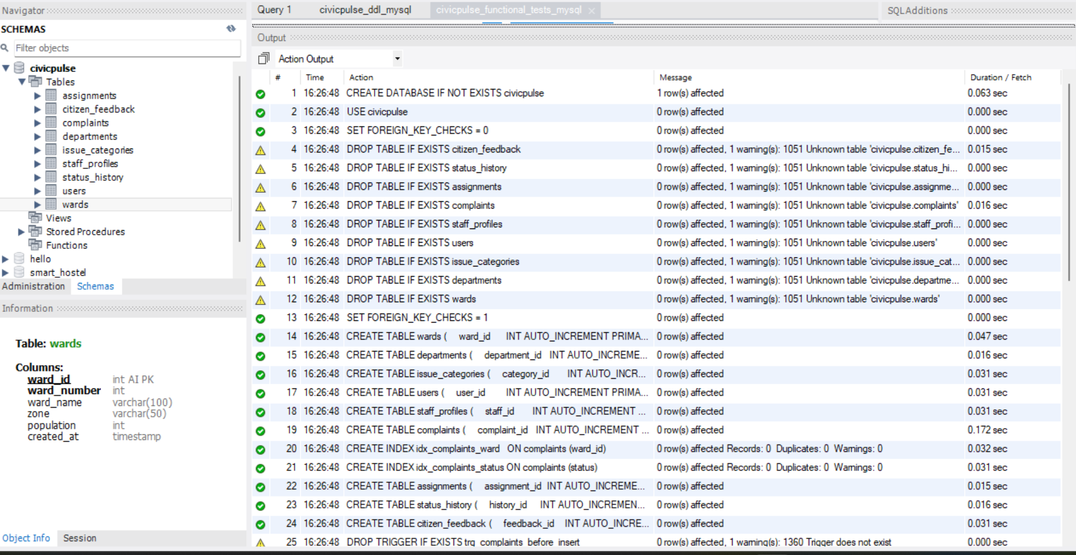

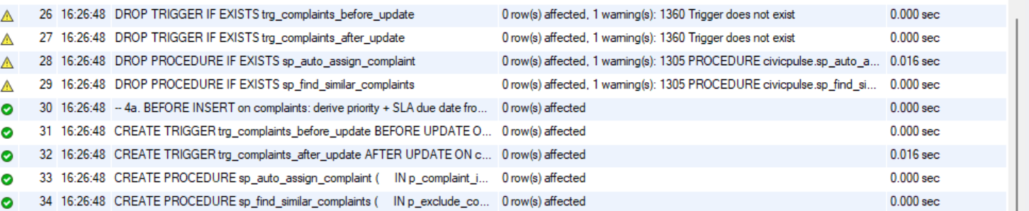

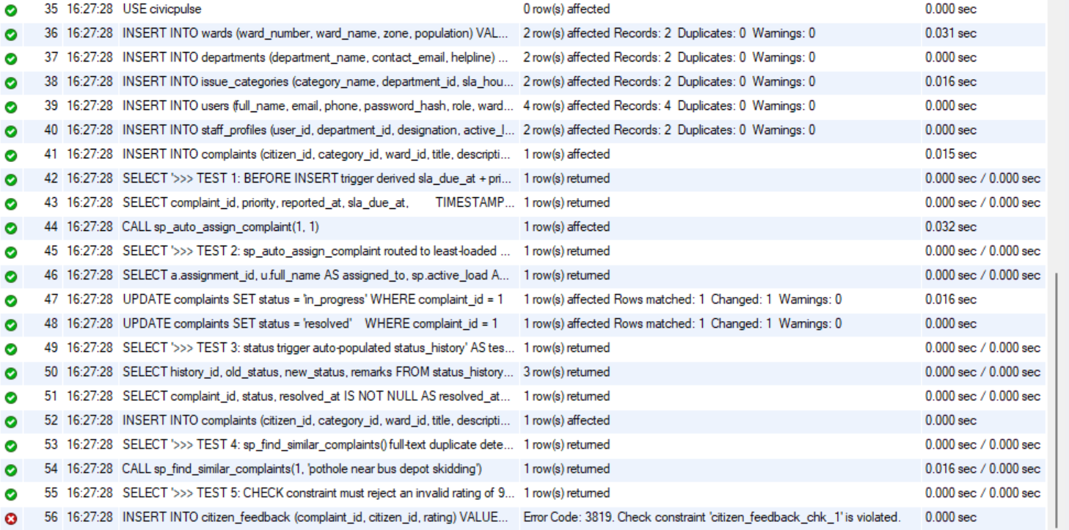

4.2 Verifying the created objects
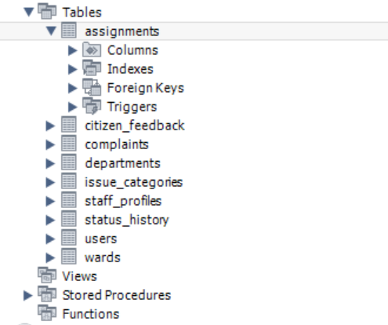
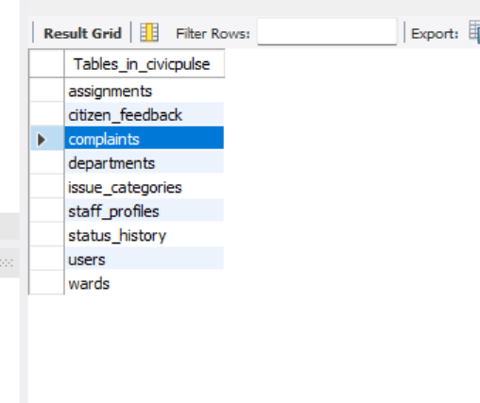
Querying the system catalogue confirms every object from the relational schema was created:
Tables: 12
Views: 2
Indexes: 30
Foreign keys: 21
Check constraints: 18
Triggers: 2
Functions/Procedures: 4

4.3 Functional verification of the schema logic
Sample master data (2 wards, 2 departments, 2 categories, 4 users, 2 field staff) was loaded, then five tests were run. Field officer Vinoth was seeded with an active load of 5 and Meera with 2, so a correct routing procedure must select Meera.
Test 1 — the BEFORE INSERT trigger must derive sla_due_at and inherit priority from the category. The 'Pothole' category carries a 72-hour SLA and 'high' priority:
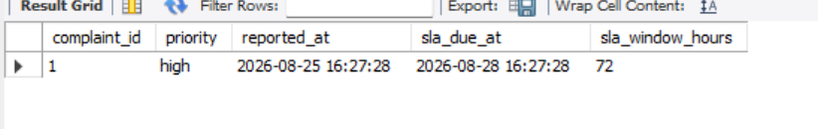
The deadline is stamped exactly 3 days out and the priority is inherited as 'high' — neither value was supplied by the INSERT.
Test 2 — the stored procedure must route to the least-loaded officer and update workload and status atomically:
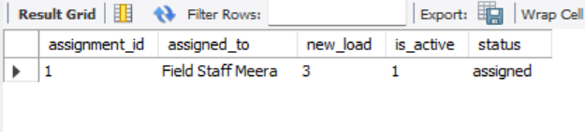
Meera was correctly selected over Vinoth, her load incremented 2 → 3, and the complaint moved to 'assigned' in the same transaction.
Test 3 — the status-change trigger must write an immutable audit trail and stamp resolved_at automatically:
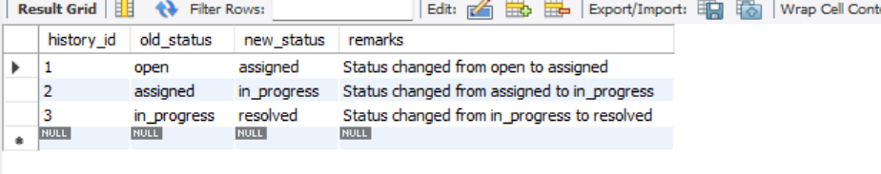
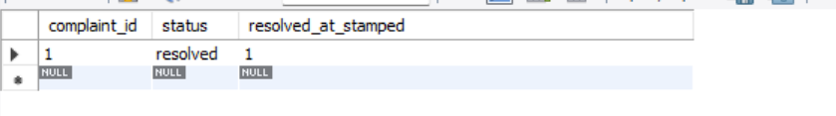
Test 4 — full-text duplicate detection must surface existing complaints describing the same physical issue:
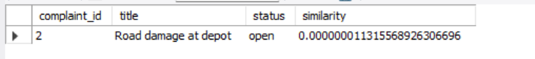
Both semantically related complaints were retrieved and ranked by relevance, demonstrating the duplicate-clustering path that the vector layer will later extend.
Test 5 — a negative test: the CHECK constraint must reject an out-of-range rating:
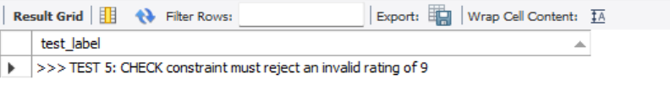
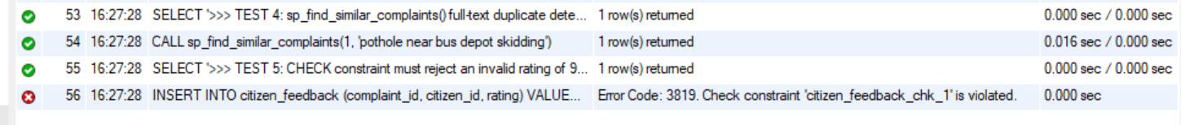

Result
All 12 CREATE TABLE statements, 10 indexes, 2 views, 2 trigger functions with their triggers, 1 stored procedure and 1 search function executed with zero errors, producing 21 foreign keys and 18 check constraints. The functional suite confirms the DDL does not merely parse: SLA derivation, workload-balanced routing, audit logging, full-text retrieval and constraint enforcement all behave exactly as the Task 2 design specifies.

